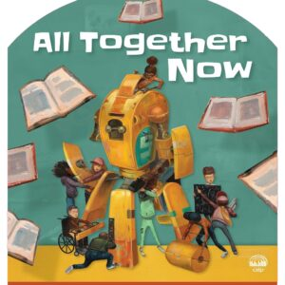

**2023 SUMMER READING PROGRAM**

**AT THE**

**SWEET SPRINGS PUBLIC LIBRARY**

**June 6th through July 25th**

**Ages 3-17**

**Read for 15 minutes per day or a total of 330 minutes from June 6th through July 25th and win a prize!**

**See Librarian for Rules**